Vigek IOT Core User Manual

Brief introduction
Vigek IOT core is a small and easy to use IOT module with wifi and camera. This module is make up of a GD32F103RG(completely compatible with STM32F103RG) Cortex M3 MCU and a RTL8189EM wifi chip. The module provide 8 GPIOs with alternative function(ADC/PWM/UART) and a cmos camera interface. You can easily use it to control your electric appliance and monitor the current scene of your home with your phone.
Figure 1. IOT core resource map V1.0
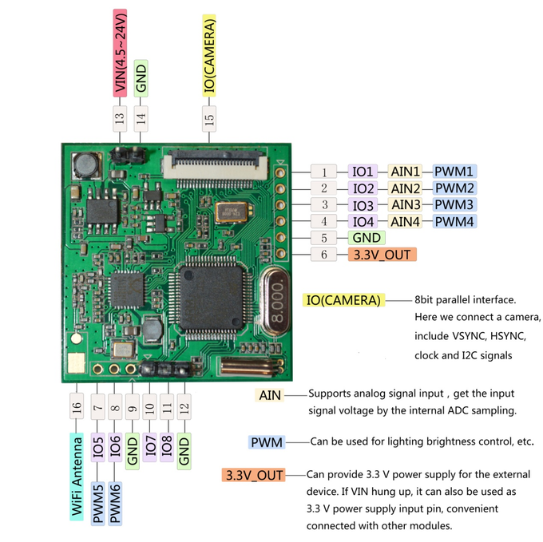
Figure 1 shows the IOT Core resource map for the older version on kickstarter. What you get is a new version of it. The new version has added a red led as an indicator of network status and few hardware simplification which have no influence on original function. What you should pay attention is that some IO’s order is different on new hardware. Figure2 shows the new version of IOT core resource map and Figure3 shows the demonstration of the new IOT Core hardware.
Figure 2. IOT core resource map V2.0
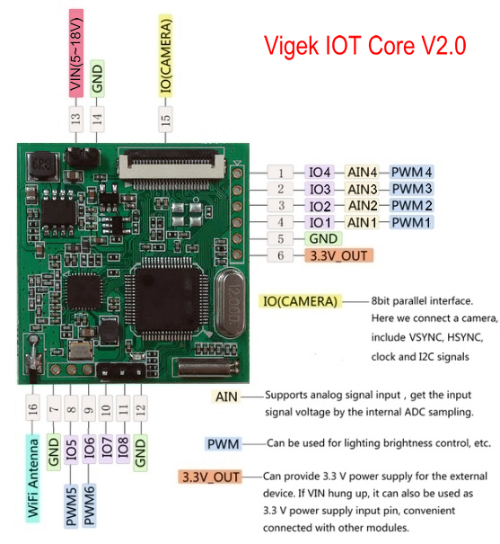

Figure 3. IOT core hardware demonstration
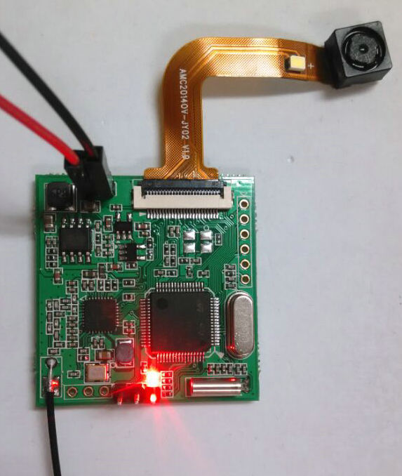
There is a flash light LED on the camera module but we can not use it due to no driven circuit.

Hardware description
As Figure 2 shows, IOT core has 8 GPIOs. All of them can be configured to output high/low level (3.3V/0V) or input a high/low level signal. While IO1~IO6 can be also configured to output PWM waveform. PWM wave frequency can be set from 2Hz to 10kHz and PWM duty can be set from 0% to 100%. What’s more IO1~IO4 can be configured to ADC(analog to digital conversion) function input pin. The reference voltage of the ADC is 3.3V and the ADC resolution is 12bit. The input analog voltage should not exceed 3.6V.

Figure 4. The back side of IOT core
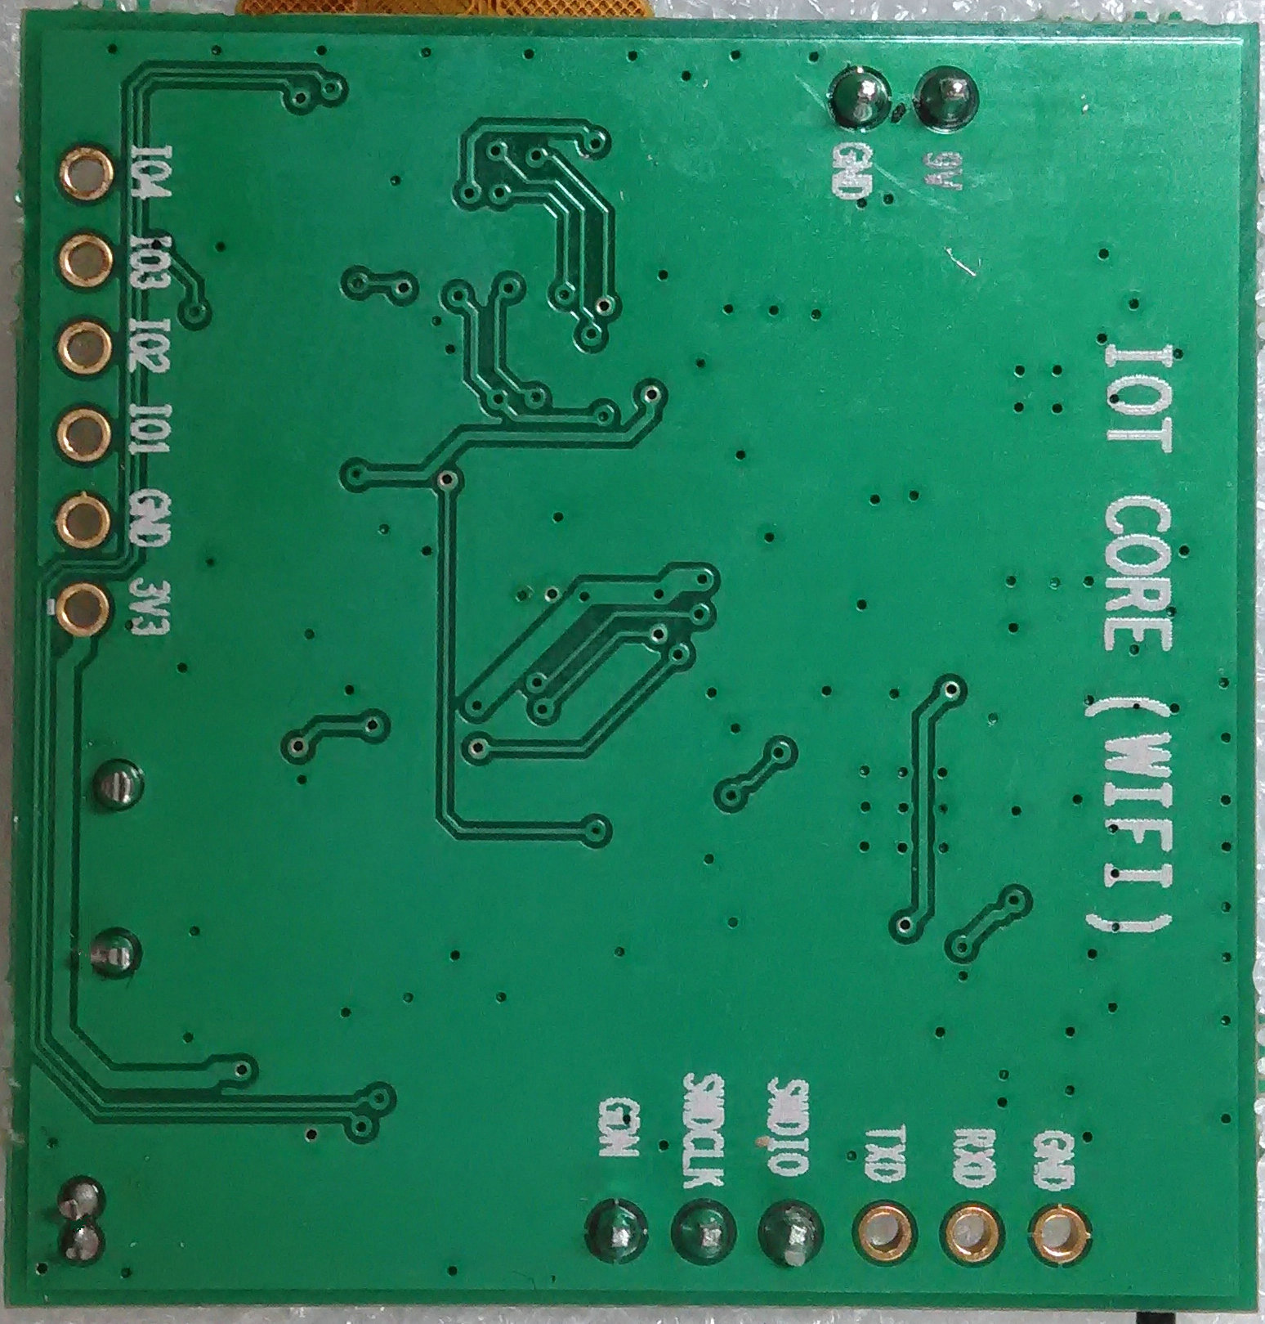
Form Figure 4 we can clearly see the IO definition on the board. IO1~IO4 can function as either general digital IO, analog input or PWM output. They are connected to PA0 ~ PA3 pins of STM32F103 as figure5 shows.

Figure 5. IO connection
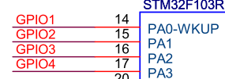
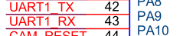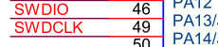
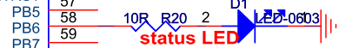
RXD, TXD, SWDIO, SWDCLK successively are IO5, IO6, IO7, IO8 which connected to PA10, PA9, PA13, PA14 pins of STM32F103. IO5 and IO6 can function as either general digital IO or PWM output. IO5 and IO6(PA10, PA9) can be also used as UART interface in STM32F103, but our firmware does not support configuring them to UART. IO7 and IO8 can only work as general digital IO. They are also firmware download and debug port. For programmers who are familiar with STM32 embed programming, you can use IOT core as an STM32F103 development kit, write your own program and download to IOT core through SWD port to make a small application. You can use J-Link or ST-Link to download firmware. Please pay attention that once IO7 or IO8 has been configured to general digital output mode, SWD function is disabled until system reset or next power on.

Quick Start Guide

IOT core WIFI configure and connect to network
When you get Viget IOT core module, you can power it up immediately by connecting a 5V~18V power supply(5V is recommended) to pin 13,14 or connect a 3.3V power supply to pin 5,6 in figure2. When power is supplied, the red status LED will light up. Different light mode of the status LED indicate different network status. They are described in Table 1. IOT core will directly enter WIFI configuration mode if it has no WIFI connection parameters. When you see the status LED starting fast blink, you can use Vigek IOTCore phone app to configure IOT core module’s WIFI connection parameters and add IOT core to the device list in the phone app. IOT core will keep WIFI configurations in the flash and connect to network automatically at next start up. If IOT core is successfully configured, it will reboot and connect to WIFI.

When your wireless router’s ssid or password has been changed, you need to reconfigure IOT core. You can connect pin 1(IO4) in figure2 to a 3.3V high level or simply connect to pin6 (3.3V) for at least 3 seconds until the status LED start fast blink and enter wifi configuration mode. This should be done before you set IO4 to output mode by sending commands to IOT core through your phone. If it can’t enter WIFI configuration mode, please restart IOT Core. Sometimes you may enter WIFI configuration mode by accident, you can again apply a high level to IO4 for not longer than 3 seconds. Then IOT core will exit WIFI configuration mode and reboot to connect to WIFI using last configuration.

Table 1. LED status vs. Network status
Status LED light mode | Network status
Fast blink, 0.1s interval | Enter into WIFI configuration mode(not connect to network)
Constantly on | System start up and initializing, trying to connect to WIFI hotspot(AP)
Blink, 1s interval, 0.5s on, 0.5s off | AP is connected and then trying to connect MQTT server
Slow blink, 2s interval, 0.1s on, 1.9s off | Connect to server OK, IOT core can receive commands and send data to phone.

In configuration mode, IOT core is not run in AP mode but in promisc mode. In this mode wifi chip can get the broadcast message from nearby wifi signals. IOT core will scan each wifi channel in turn, trying to get the configuration parameters send by phone app during configuring. Once parameters was get, IOT core will try to connect the router and send an ACK to phone when connect OK.

You can follow these steps to configure IOT core:
1. Set IOT core to configuration mode. Above paragraphs has described how to do it.
2. Open your phone app “IOTCore”, press “ADD DEVICE”, then press “PREPARED” .

Figure 6. Add device
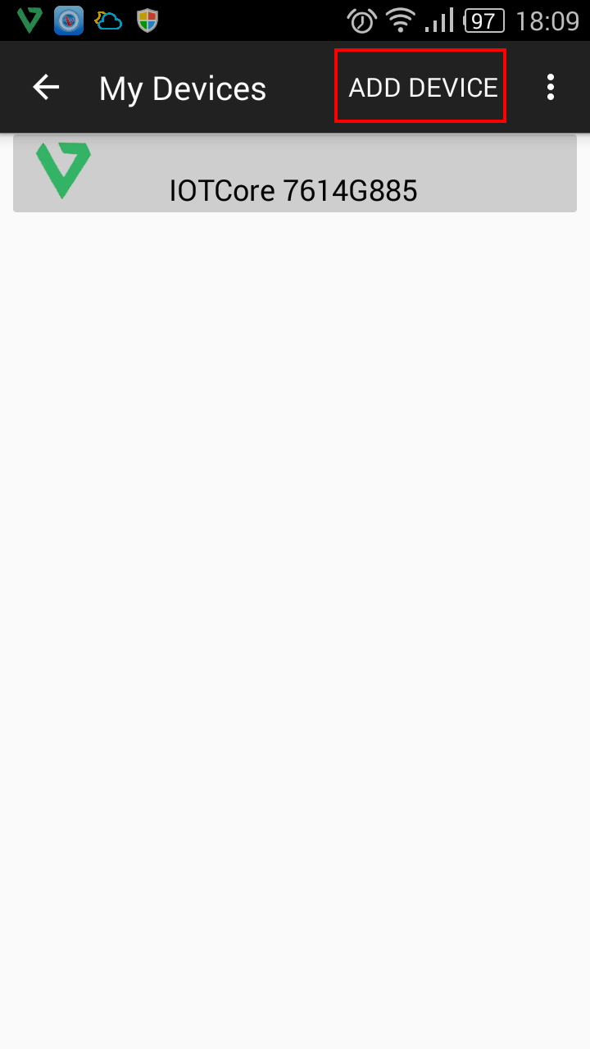
3. Select the SSID which you want IOT core to connect to and input password then press “START” to start configuration. If the password area is not empty, you can directly press “START” to start configuration.
Figure 7. Set SSID and password
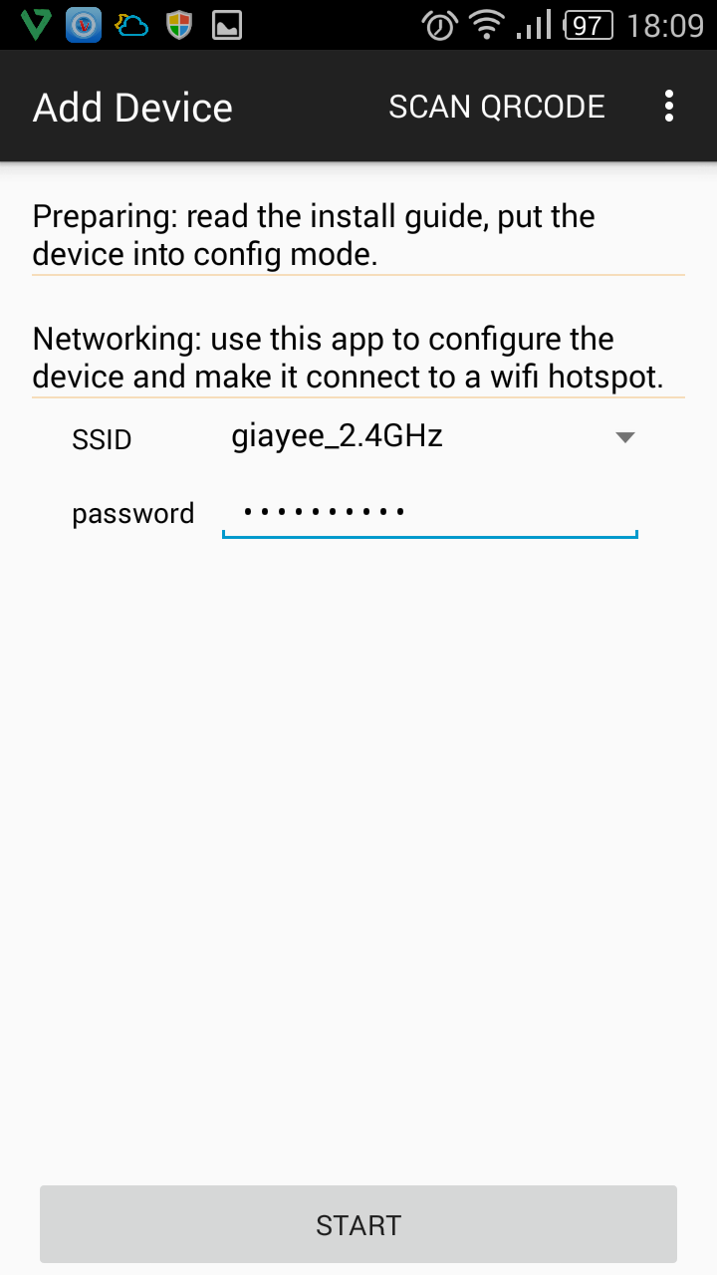
4. Wait for a few seconds. When configuration process ended, press “ADD” . Then device will be added to device list. IOT core will reboot later.

Figure 8. Configuration OK
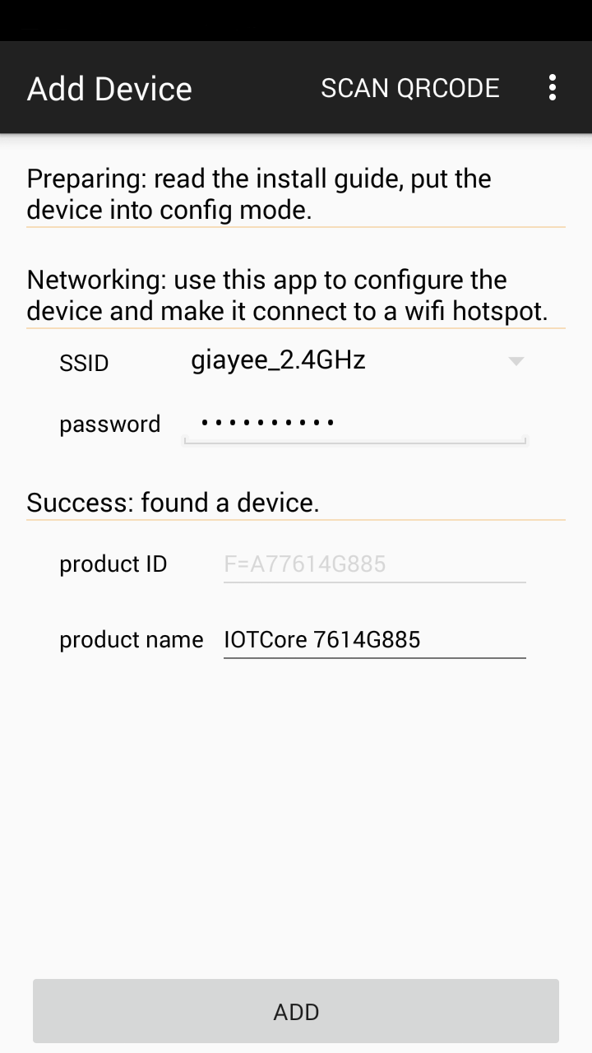

Use your phone to control IOT core
When the status LED turned to slow blink, it indicate IOT core has connected to MQTT server and now you can use IOTCore phone app (Figure 9) to control the IO’s output level, PWM waveform or capture a photo. The demo PWM waveform is 50Hz, 50% duty as default. The control result reflect on IOT core may have some delay due to network delay. Photo capture operation has more delay due to camera initialization, exposure and image data collection. This delay can be more than 3 seconds. The image data are encoded in JPEG format. Limited by micro controller’s internal RAM size, the photo’s size is limited to 640x480 max. The JPEG data size of the photo is varying with the complexity of the photo. If the scene took by the camera contains lots of details, the photo’s data size becomes big and may exceed MCU’s internal buffer size. This will lead to operation failed. In this condition MCU will set camera to lower resolution(480x320 or 320x240 if 480x320 still failed) and try to take photo again. This will take more time for the phone to get the photo after sending capture command.
IOT core’s IO output current is a few mA which is not enough to directly drive high current devices like relay, motor, light etc. You need to connect a driven circuit to do that. If you want to drive a high voltage device, it’s essential to use an isolation driven circuit to protect IOT core from being damaged by external high voltage. Figure10 shows two examples of the driving circuit, you can chose the appropriate one as a reference for your application.
Since IO4 is used as entering WIFI configuration mode pin at system start up. IOT core will switch to WIFI configuration mode if IO4 input a high level for more than 3 seconds. If you connect this IO to drive an external circuit which has a pull up function, you’d better not connect this kind external circuit before configure IO4 to output mode or IOT core will run into configuration mode.

Figure 9. Phone app
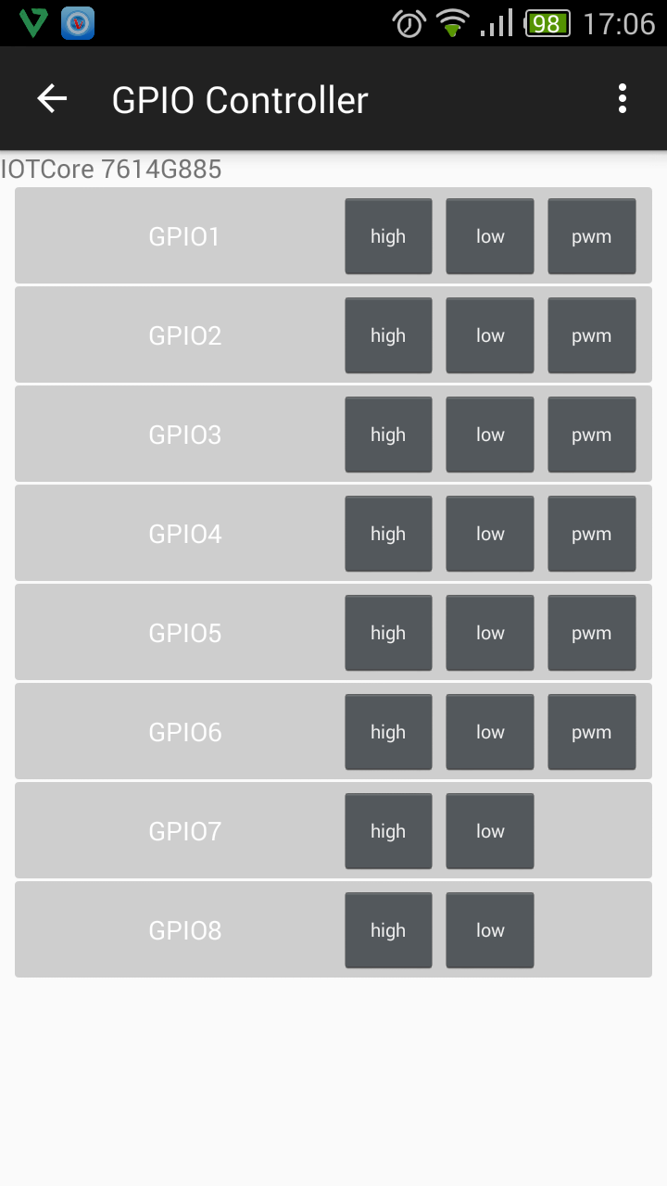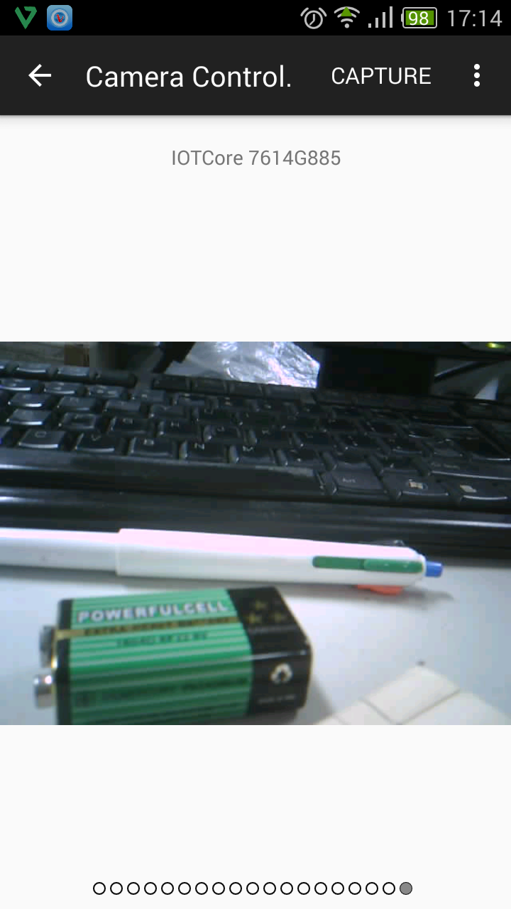

Figure 10. Application circuit
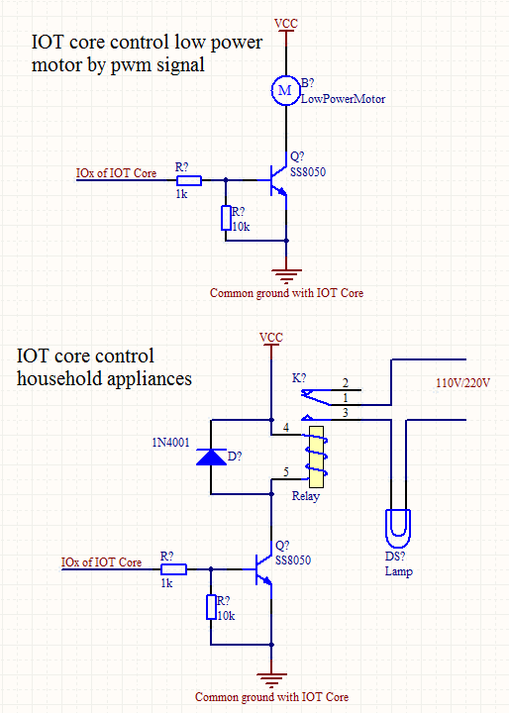

Software Customize

On MCU side
We provide some customizable function in IOT core SDK. You can change it as your need. Then build the project and download to IOT core. Download tool and download port is introduced at the end of chapter 2. The SDK can be built with Keil MDK for ARM or IAR System for ARM (IAR will be supported later). We provide an mqtt_api.h which contains APIs to set mqtt server address/port and publish messages and a user_task.c which contains an empty task loop and a callback function for you to send message and deal with received data. For more detailed information please refer to the source file comment.

On phone app side
Please refer to https://github.com/IotCore/IotCore/blob/master/docs/mqttser
vice%20API%201.0.doc

IOT core control command raw data format
For developers who want to make full use of IOT core we give out the definition of the raw IO control command format. You can use phone app or other machines which can run MQTT service to publish control commands to control IOT core. IOT core use the iot.eclipse.org:1883 as the default MQTT server.

IOT core control topic
IO control commands are publish to “io_ctrl” topic. In fact there is a 12 bytes serial number string and a slash prefix in front of the “io_ctrl” topic name to distinguish different device message. So an IO control topic maybe “serialnumber/io_ctrl”. The serial number is generated from MCU’s chip id. It can be got when using the phone app to configure IOT core’s WIFI parameters and will be displayed on device control page after device is added to the device list. All control commands go through this topic include image capture command. Captured images which published by MCU will got through another topic “photo”(actually “serialnumber/photo”) and phone app will subscribe this topic to get the image. User can configure the IOT core SDK to determine whether the topic names include serial number or not.

Figure 11. Device serial number showing on control page
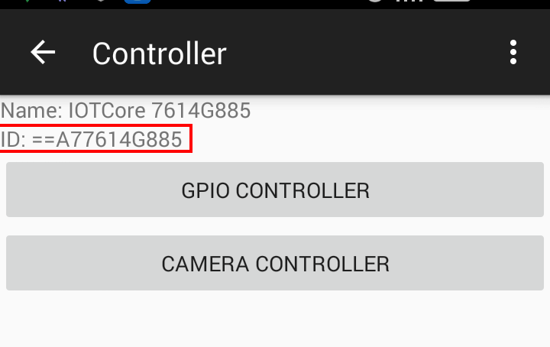

The control command data format is defined as below:
Command data header (6 bytes):
typedef struct _ha_cmd_head {
uint8_t constid[2]; // Always BB 00
uint8_t cmd; // command type
uint8_t cmd_status; // used for returning cmd status
uint8_t datalen[2]; // little endian
}cmd_head_t;

“cmd” can be the following values:
enum {
CMD_GET_DEVICE_INFO = 1,
CMD_IO_CTRL_WRITE = 0x0C,
CMD_IO_CTRL_READ = 0x0D,
CMD_IO_CTRL_RETURN = 0x0E
};

Command data payload (34 bytes):
struct gpio_ctrl_struct{
uint8_t io_mode; // GPIO input/output mode
uint8_t io_mode_last; // used by program, keep to 0 when sending cmd
uint8_t io_polarity; // GPIO input/output polarity
uint8_t io_pupd; // IO pull up or pull down config
union {
uint32_t input;
// Store input value when IO is set to input mode. (this field stores the ADC conversion result for analog input IO or store 0/1(low/high level) for digital input)

uint32_t output;
// Store output value (0 or 1) when IO is set to output mode. 0 or 1 means output disable or enable. The real output level is also determined by io_polarity’s value.

struct pwm_data pwm;
// Store PWM duty and frequency when IO is set to PWM mode
}pin_data;

uint16_t high_level; // set the high threshold when IO is set to AIN mode

uint16_t low_level; // set the low threshold when IO is set to AIN mode

uint32_t start_time;
// specify the start executing time of the current command. Setting to 0xFFFFFFFF means start right now. This time is a Unix time stamp in second unit starting from 1970-1-1 0:0:0.

uint32_t delay_time;
// specify the execution length of the command, minimum 1 second, maximum 24*3600s. After execution length, IO will switch to disable mode. If delay_time is set to 0 IO will not switch to disable mode.

uint32_t event_period;
// specify the execution period for periodic control event. 0 means none periodic event.

uint32_t total_period; // how many periodic control will be executed
uint32_t next_time; // reserved to 0

uint8_t event_pended_flag;
// LSB(lowest bit) == 1 will pend an IO control event, it will be automatically cleared by MCU software.
uint8_t related_io; // reserved
};

io_mode’s value can be set to following values:
#define GPIO_MODE_NONE 0
#define GPIO_MODE_AIN 1
#define GPIO_MODE_DIN 2
#define GPIO_MODE_DOUT 3
#define GPIO_MODE_PWM 4

io_pupd’s value can be set to following values:
#define GPIO_PUPD_FLOAT 0
#define GPIO_PUPD_PU 1
#define GPIO_PUPD_PD 2

PWM data structure is defined as below
struct pwm_data{
uint16_t pwm_duty;
uint16_t pwm_period;
};

All time relate values are in unit of second.

Here we give some examples of IO control command data (all in hex format)
- IO1 constantly output a high level right now
0xBB 00 0C 00 23 00 01 03 00 01 00 01 00 00 00 00 00 00 00 FF FF FF FF 00 00 00 00 00 00 00 00 00 00 00 00 00 00 00 00 01 00
Explanation:
Element | Size | Value (little endian) | Description
constid | 2 bytes | BB 00 | Constant flag
cmd | 1 byte | 0C | Cmd: CMD_IO_CTRL_WRITE
cmd_status | 1 byte | 00 | Reserve to 0
data_len | 2 bytes | 23 00 | Remain data length
Io_number | 1 byte | 01 | Specify IO1 to be controlled
io_mode | 1 byte | 03 | Digital output mode
Io_mode_last | 1 byte | 00 | Reserve to 0
Io_polarity | 1 byte | 01 | High level effective
Io_pupd | 1 byte | 00 | No pull up/down
pin_data | 4 bytes | 01 00 00 00 | Output enable
high_level | 2 bytes | 00 00 | Not used. Reserve to 0
low_level | 2 bytes | 00 00 | Not used. Reserve to 0
start_time | 4 bytes | FF FF FF FF | Start time now
delay_time | 4 bytes | 00 00 00 00 | Always effective
event_period | 4 bytes | 00 00 00 00 | Not a periodic event
total_period | 4 bytes | 00 00 00 00 | Not used. Reserve to 0
next_time | 4 bytes | 00 00 00 00 | Reserve to 0
event_pended_flag | 1 byte | 01 | pend an IO control event
related_io | 1 byte | 00 | Reserve to 0

- IO2 constantly output a PWM waveform right now
0xBB 00 0C 00 23 00 02 04 00 01 00 32 00 32 00 00 00 00 00 FF FF FF FF 00 00 00 00 00 00 00 00 00 00 00 00 00 00 00 00 01 00

Element |  | Size | Value (little endian) | Description
constid |  | 2 bytes | BB 00 | Constant flag
cmd |  | 1 byte | 0C | Cmd: CMD_IO_CTRL_WRITE
cmd_status |  | 1 byte | 00 | Reserve to 0
data_len |  | 2 bytes | 23 00 | Remain data length
Io_number |  | 1 byte | 02 | Specify IO2 to be controlled
io_mode |  | 1 byte | 04 | PWM waveform output mode
Io_mode_last |  | 1 byte | 00 | Reserve to 0
Io_polarity |  | 1 byte | 01 | High level effective
Io_pupd |  | 1 byte | 00 | No pull up/down
pin_data | PWM duty | 2 bytes | 32 00 | 50% duty
pin_data | PWM freq | 2 bytes | 32 00 | 50Hz frequency
high_level |  | 2 bytes | 00 00 | Not used. Reserve to 0
low_level |  | 2 bytes | 00 00 | Not used. Reserve to 0
start_time |  | 4 bytes | FF FF FF FF | Start time now
delay_time |  | 4 bytes | 00 00 00 00 | Always effective
event_period |  | 4 bytes | 00 00 00 00 | Not a periodic event
total_period |  | 4 bytes | 00 00 00 00 | Not used. Reserve to 0
next_time |  | 4 bytes | 00 00 00 00 | Reserve to 0
event_pended_flag |  | 1 byte | 01 | pend an IO control event
related_io |  | 1 byte | 00 | Reserve to 0

- Capture a photo right now
0xBB 00 0C 00 23 00 09 00 00 00 00 00 00 00 00 00 00 00 00 FF FF FF FF 00 00 00 00 00 00 00 00 00 00 00 00 00 00 00 00 01 00
Explanation:
Element | Size | Value (little endian) | Description
constid | 2 bytes | BB 00 | Constant flag
cmd | 1 byte | 0C | Cmd: CMD_IO_CTRL_WRITE
cmd_status | 1 byte | 00 | Reserve to 0
data_len | 2 bytes | 23 00 | Remain data length
Io_number | 1 byte | 09 | Camer is treated as IO9
io_mode | 1 byte | 00 | Not used. Reserve to 0
Io_mode_last | 1 byte | 00 | Reserve to 0
Io_polarity | 1 byte | 00 | Not used. Reserve to 0
Io_pupd | 1 byte | 00 | Not used. Reserve to 0
pin_data | 4 bytes | 00 00 00 00 | Not used. Reserve to 0
high_level | 2 bytes | 00 00 | Not used. Reserve to 0
low_level | 2 bytes | 00 00 | Not used. Reserve to 0
start_time | 4 bytes | FF FF FF FF | Start time now
delay_time | 4 bytes | 00 00 00 00 | Not used. Reserve to 0
event_period | 4 bytes | 00 00 00 00 | Not a periodic event
total_period | 4 bytes | 00 00 00 00 | Not used. Reserve to 0
next_time | 4 bytes | 00 00 00 00 | Reserve to 0
event_pended_flag | 1 byte | 01 | pend an IO control event
related_io | 1 byte | 00 | Reserve to 0
Image data will be directly published to photo topic with out modification if image is successfully captured.

- IO3 read input level right now
0xBB 00 0C 00 23 00 03 02 00 00 02 00 00 00 00 00 00 00 00 FF FF FF FF 00 00 00 00 00 00 00 00 00 00 00 00 00 00 00 00 01 00
Explanation:
Element | Size | Value (little endian) | Description
constid | 2 bytes | BB 00 | Constant flag
cmd | 1 byte | 0C | Cmd: CMD_IO_CTRL_WRITE
cmd_status | 1 byte | 00 | Reserve to 0
data_len | 2 bytes | 23 00 | Remain data length
Io_number | 1 byte | 03 | Specify IO3 to be controlled
io_mode | 1 byte | 02 | Digital input mode
Io_mode_last | 1 byte | 00 | Reserve to 0
Io_polarity | 1 byte | 00 | Not used
Io_pupd | 1 byte | 02 | Pull down
pin_data | 4 bytes | 00 00 00 00 | Not used, MCU will return value
high_level | 2 bytes | 00 00 | Not used. Reserve to 0
low_level | 2 bytes | 00 00 | Not used. Reserve to 0
start_time | 4 bytes | FF FF FF FF | Start time now
delay_time | 4 bytes | 00 00 00 00 | Always effective
event_period | 4 bytes | 00 00 00 00 | Not a periodic event
total_period | 4 bytes | 00 00 00 00 | Not used. Reserve to 0
next_time | 4 bytes | 00 00 00 00 | Reserve to 0
event_pended_flag | 1 byte | 01 | pend an IO control event
related_io | 1 byte | 00 | Reserve to 0
The specified pin level value will be returned by MCU through status topic which will be described in chapter 5.2.

- IO4 read analog input value right now
0xBB 00 0C 00 23 00 04 01 00 00 00 00 00 00 00 00 00 00 00 FF FF FF FF 00 00 00 00 00 00 00 00 00 00 00 00 00 00 00 00 01 00
Explanation:
Element | Size | Value (little endian) | Description
constid | 2 bytes | BB 00 | Constant flag
cmd | 1 byte | 0C | Cmd: CMD_IO_CTRL_WRITE
cmd_status | 1 byte | 00 | Reserve to 0
data_len | 2 bytes | 23 00 | Remain data length
Io_number | 1 byte | 04 | Specify IO4 to be controlled
io_mode | 1 byte | 01 | Analog input mode
Io_mode_last | 1 byte | 00 | Reserve to 0
Io_polarity | 1 byte | 00 | Not used
Io_pupd | 1 byte | 00 | Not used
pin_data | 4 bytes | 00 00 00 00 | Not used, MCU will return value
high_level | 2 bytes | 00 00 | Not used. Reserve to 0
low_level | 2 bytes | 00 00 | Not used. Reserve to 0
start_time | 4 bytes | FF FF FF FF | Start time now
delay_time | 4 bytes | 00 00 00 00 | Always effective
event_period | 4 bytes | 00 00 00 00 | Not a periodic event
total_period | 4 bytes | 00 00 00 00 | Not used. Reserve to 0
next_time | 4 bytes | 00 00 00 00 | Reserve to 0
event_pended_flag | 1 byte | 01 | pend an IO control event
related_io | 1 byte | 00 | Reserve to 0
The specified pin analog input value will be returned by MCU through status topic which will be described in chapter 5.2.

- Get IOT core information
0xBB 00 01 00 00
Element | Size | Value (little endian) | Description
constid | 2 bytes | BB 00 | Constant flag
cmd | 1 byte | 01 | Cmd: CMD_GET_DEVICE_INFO
cmd_status | 1 byte | 00 | Reserve to 0
data_len | 2 bytes | 00 00 | Remain data length
The requested information data will be return by MCU through status topic.

IOT core status topic
This topic is used to return IOT core’s information or the result of input pin data. Phone can get IOT core’s information like its chip id, IP address, mac address and so on. These information are returned by MCU through “serialnumber/ status” topic.
- Returned IO input value message format definition:
typedef struct ioctrl_feedback_struct {
cmd_head_t head; // header
uint8_t pin_number; // IO number
uint8_t pin_mode; // analog input or digital input
uint32_t pin_value; // analog or digital input value
uint32_t time_stamp; // Unix time stamp
} ioctrl_resp_t;
For example, after an IO2 analog read command sending to IOT core. IOT core will send back response message:
0xBB 00 0C 01 0C 00 02 01 58 07 00 00 89 AB 04 56
Element | Size | Value (little endian) | Description
constid | 2 bytes | BB 00 | Constant flag
cmd | 1 byte | 0C | Cmd: CMD_GET_DEVICE_INFO
cmd_status | 1 byte | 00 | Reserve to 0
data_len | 2 bytes | 0C 00 | Remain data length
pin_number | 1 byte | 02 | Specify IO2
pin_mode | 1 byte | 01 | Analog input mode
pin_value | 4 bytes | 58 07 00 00 | Analog input value is 0x0758(total 12bits, max 0xFFF, Vref == 3.3V)
time_stamp | 4 bytes | 89 AB 04 56 | Time stamp is 0x5604AB89. Convert this Unix time stamp to local time is 2015/09/25 10:03:53

- Returned device information message format definition:
struct device_info_feedback_struct {
cmd_head_t head; // header
uint8_t *info; // information payload
};
The information payload data are all ascii string which can be printed. Payload ontents can be as follows:
serialnum: xxxxxxxxxxxx
chipid: xxxxxxxxxxxx // In hex format
ssid: xxxxx
ip: xxx.xxx.xxx.xxx
mac: xxxxxx // In hex format

